Project Design Phase-II
Data Flow Diagram & User Stories
Date | 20 February 2026
Team ID | LTVIP2026TMIDS41611
Project Name | OrderOnTheGo: Your On-Demand Food Ordering Solution
Maximum Marks | 4 Marks

Data Flow Diagrams:
DFD Level 0:
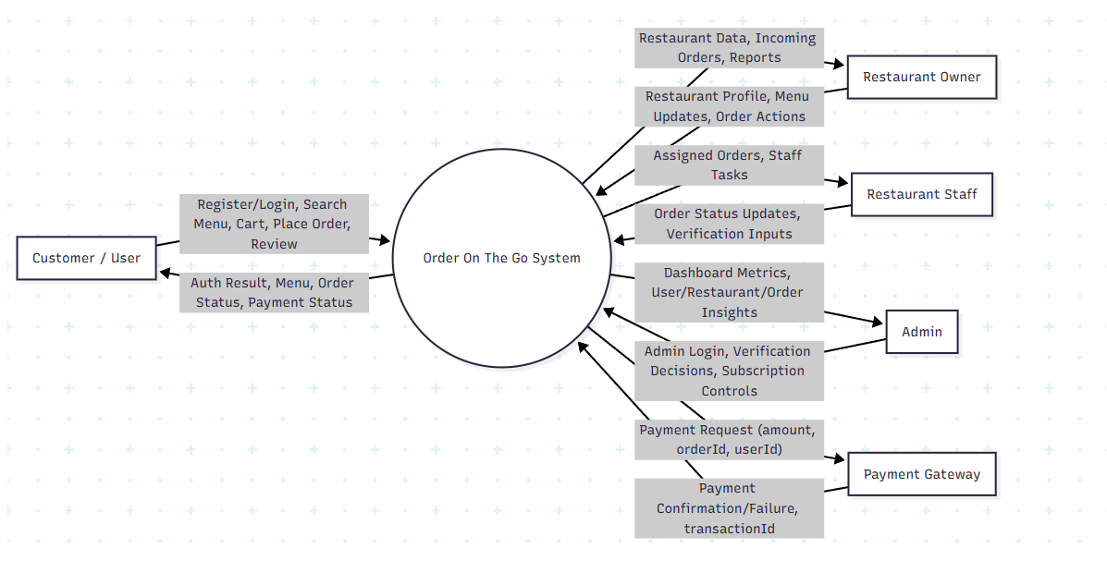
DFD Level 1:
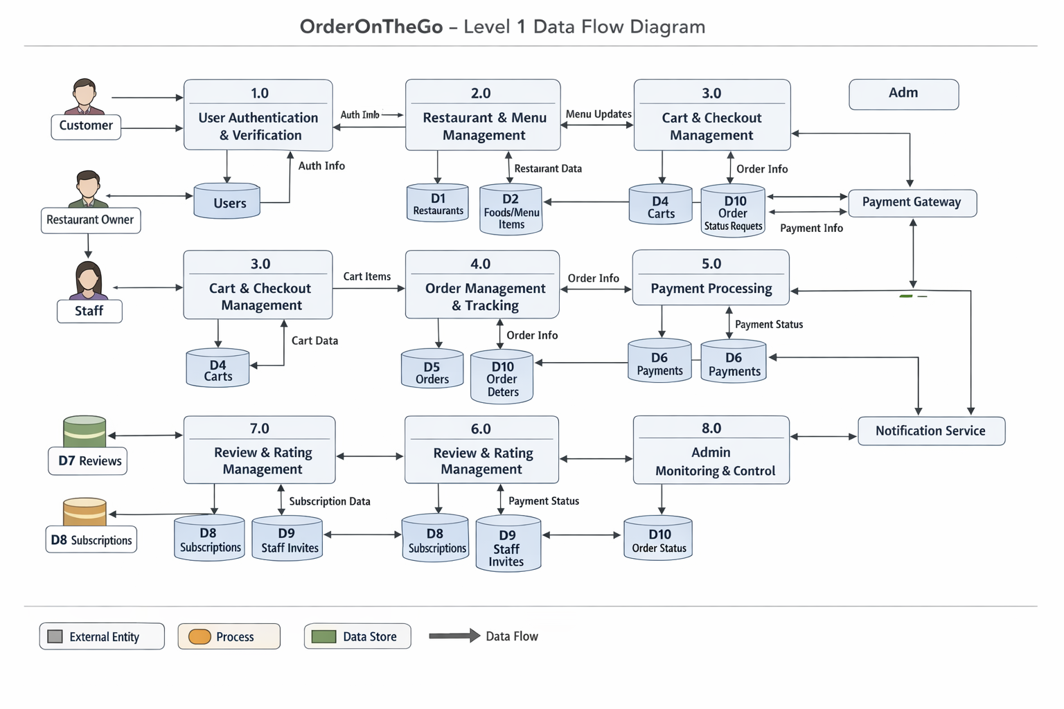
DFD Level 2:
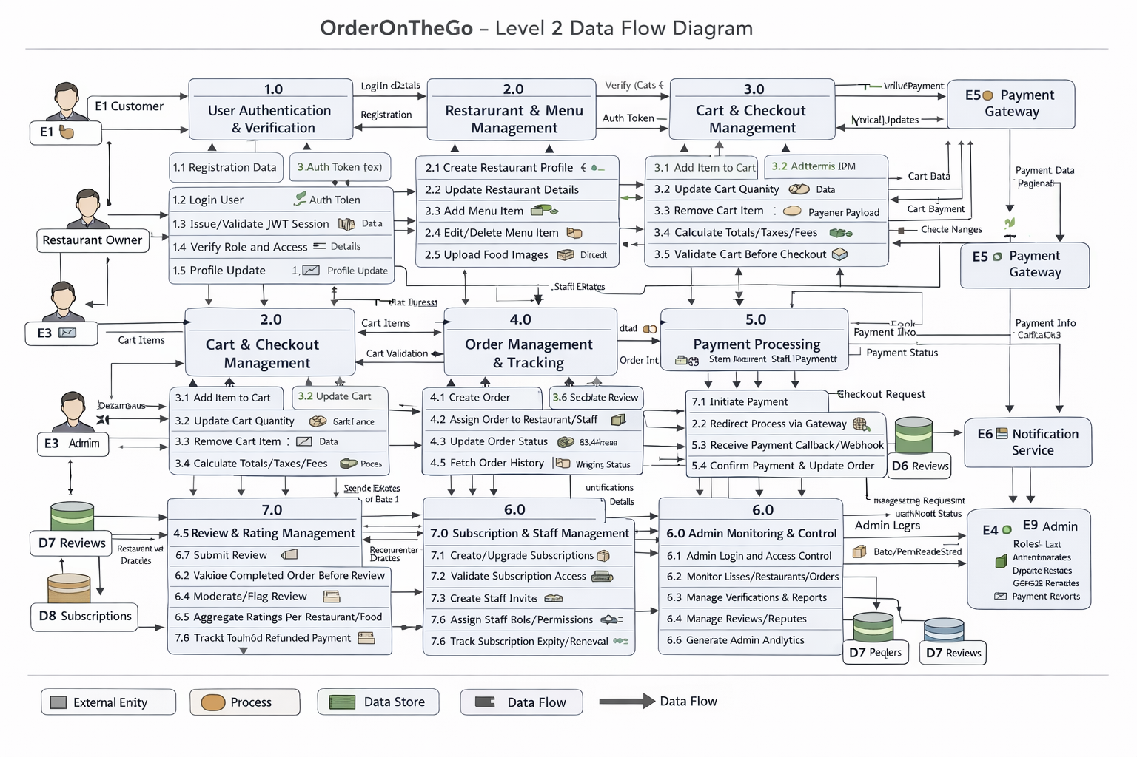

User Stories
Use the below template to list all the user stories for the product.
User Type | Functional Requirement (Epic) | User Story Number | User Story / Task | Acceptance criteria | Priority | Release
Customer (Mobile user) | Registration | USN-1 | As a user, I can register using email, password, and confirm password. | Account is created and user is redirected to dashboard/home. | High | Sprint-1
Customer (Mobile user) | Registration | USN-2 | As a user, I will receive confirmation email once I have registered for the application. | User receives confirmation email and can verify account from link/code. | High | Sprint-1
Customer (Mobile user) | Registration | USN-3 | As a user, I can register for the application through Facebook | User can sign up/login and access dashboard with Facebook account. | Low | Sprint-2
Customer (Mobile user) | Registration | USN-4 | As a user, I can register for the application through Gmail. | User can sign up/login and access dashboard with Gmail account. | Medium | Sprint-1
Customer (Mobile user) | Login | USN-5 | As a user, I can log into the application by entering email & password | Valid credentials log user in and open home/dashboard. | High | Sprint-1
Customer (Mobile user) | Dashboard | USN-6 | As a user, I can view nearby restaurants and featured foods on dashboard. | Dashboard shows restaurant list, food cards, and quick navigation. | High | Sprint-1
Customer (Mobile user) | Food Discovery | USN-7 | As a user, I can search foods/restaurants by name or category. | Search returns relevant results with clear empty-state if none found. | High | Sprint-1
Customer (Mobile user) | Cart & Checkout | USN-8 | As a user, I can add items to cart and update quantity. | Cart updates totals in real time and persists for logged-in user. | High | Sprint-1
Customer (Mobile user) | Orders | USN-9 | As a user, I can place an order from my cart. | Order is created successfully and order ID is generated. | High | Sprint-1
Customer (Mobile user) | Payments | USN-10 | As a user, I can pay online for my order. | Payment is processed and status is saved against order. | High | Sprint-1
Customer (Mobile user) | Order Tracking | USN-11 | As a user, I can track my order status from placed to delivered. | Status timeline updates through defined order lifecycle. | High | Sprint-1
Customer (Mobile user) | Reviews | USN-12 | As a user, I can rate and review delivered food items. | User can add/update/delete own review; average rating refreshes. | Medium | Sprint-2
Customer (Web user) | Authentication | USN-13 | As a web user, I can register and login with email/password. | User session starts and protected pages are accessible. | High | Sprint-1
Customer (Web user) | Restaurant Browsing | USN-14 | As a web user, I can browse all restaurants and menus. | User can open restaurant details and view available foods. | High | Sprint-1
Customer (Web user) | Checkout | USN-15 | As a web user, I can checkout with cart summary and delivery address. | Address validation works and order is created only with valid inputs. | High | Sprint-2
Customer (Web user) | Order History | USN-16 | As a web user, I can view my past orders. | Order history shows status, amount, and order date details. | Medium | Sprint-2
Customer (Web user) | Profile | USN-17 | As a web user, I can update my profile and profile image. | Updated profile fields are saved and reflected immediately. | Medium | Sprint-2
Customer (Web user) | Support Operations | USN-18 | As a support executive, I can search customers and orders by ID/email/phone. | Search returns correct records with pagination and filters. | High | Sprint-2
Customer (Web user) | Complaint Handling | USN-19 | As a support executive, I can create and update complaint tickets. | Ticket status and notes are saved with timestamp and owner. | High | Sprint-2
Customer (Web user) | Order Assistance | USN-20 | As a support executive, I can view full order timeline for customer queries. | Timeline includes all status transitions and payment state. | High | Sprint-2
Customer (Web user) | Escalations | USN-21 | As a support executive, I can escalate unresolved cases to admin. | Escalation is tagged, assigned, and visible in admin queue. | Medium | Sprint-3
Customer (Web user) | Refund Support | USN-22 | As a support executive, I can initiate refund requests for failed/cancelled orders | Refund request is logged and moves through approval workflow. | Medium | Sprint-3
Administrator | Access & Security | USN-23 | As an admin, I can login securely and access admin dashboard only with admin role. | Non-admin users are blocked from admin routes. | High | Sprint-1
Administrator | Dashboard Analytics | USN-24 | As an admin, I can view platform KPIs (orders, users, revenue, status distribution). | Dashboard loads accurate metrics and 7-day analytics. | High | Sprint-1
Administrator | User Management | USN-25 | As an admin, I can view users and change status (active/inactive/banned). | User list supports search/pagination; status changes persist. | High | Sprint-1
Administrator | Restaurant Approval | USN-26 | As an admin, I can approve or reject restaurant registrations. | Restaurant state updates immediately and action is auditable | High | Sprint-1
Administrator | Order Governance | USN-27 | As an admin, I can view and update any order status when required. | Admin status update reflects in order timeline and history. | Medium | Sprint-1
Administrator | Data Management | USN-28 | As an admin, I can delete fraudulent or invalid users/orders. | Delete action requires confirmation and record is removed safely. | Medium | Sprint-2
Administrator | Food Governance | USN-29 | As an admin, I can monitor and manage food items across restaurants. | Admin can view/edit/remove items violating policy. | Medium | Sprint-2
Administrator | Staff Governance | USN-30 | As an admin, I can monitor staff accounts and approval flows. | Staff state and invite/approval records are viewable and editable. | Medium | Sprint-2
Administrator | Subscription Management | USN-31 | As an admin, I can track plan usage and subscription revenue | Plan-wise metrics and restaurant usage limits are visible. | Medium | Sprint-2
Administrator | Verification Monitoring | USN-32 | As an admin, I can monitor email/SMS verification outcomes. | Verification logs show success/failure and resend attempts. | Low | Sprint-3

